39.32: The same.
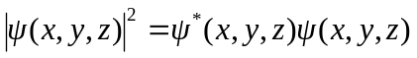
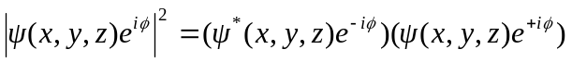
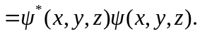
The complex conjugate means convert all ’s to 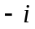’s and vice-versa. 